Deployment Instructions steps :

1. Install Python and PIP

sudo apt install -y python3-pip

1. Inatall Virtualenv

pip install virtualenv

1. Create Virtual Environment

virtualenv env

1. Activate Virtual Environment

env/scripts/activate

1. Install all packages in Virtual Environment

pip install –r requirements.txt

1. Allow Port 80 in firewall

sudo ufs allow 80

1. Allow hosts in settings.py

add ip of your server to ALLOWED_HOSTS in settings.py

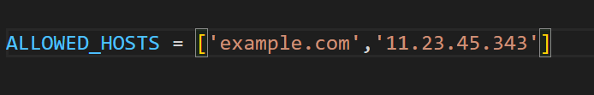

1. Run wsgi server using gunicorn

gunicorn –bind 0.0.0.0:80 shopping_cart.wsgi